https://www.cnblogs.com/youzhibing/p/6849843.html

[**从源码来理解slf4j的绑定，以及logback对配置文件的加载**](https://www.cnblogs.com/youzhibing/p/6849843.html)

**前言**

　　项目中的日志系统使用的是slf4j + logback。slf4j作为一个简单日志门面，为各种loging APIs（像java.util.logging, logback, log4j）提供一个简单统一的接口，有利于维护和各个类的日志处理方式统一。Logback作为一个具体的日志组件，完成具体的日志操作。

本博客旨在带领大家理清楚slf4j的绑定(logback如何绑定到slf4j的)，logback是何时加载配置文件的。至于具体的配置则需要大家自己去查阅资料了。

　　路漫漫其修远兮，吾将上下而求索！

　　github：[https://github.com/youzhibing](https://github.com/youzhibing" \t "_blank)

　　码云(gitee)：[https://gitee.com/youzhibing](https://gitee.com/youzhibing" \t "_blank)

**slf4j + logback的使用**

　　使用非常简单，引入依赖的jar即可，如下图

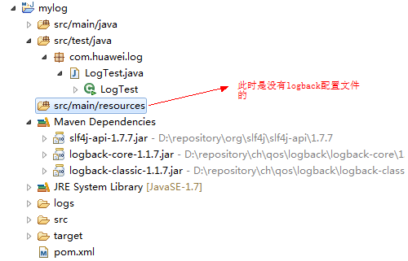

　　pom.xml

https://images.cnblogs.com/OutliningIndicators/ExpandedBlockStart.gif

<project xmlns="http://maven.apache.org/POM/4.0.0" xmlns:xsi="http://www.w3.org/2001/XMLSchema-instance"

xsi:schemaLocation="http://maven.apache.org/POM/4.0.0 http://maven.apache.org/xsd/maven-4.0.0.xsd">

<modelVersion>4.0.0</modelVersion>

<groupId>com.yzb</groupId>

<artifactId>mylog</artifactId>

<version>0.0.1-SNAPSHOT</version>

<packaging>jar</packaging>

<name>mylog</name>

<url>http://maven.apache.org</url>

<properties>

<project.build.sourceEncoding>UTF-8</project.build.sourceEncoding>

<maven.compiler.source>1.7</maven.compiler.source>

<maven.compiler.target>1.7</maven.compiler.target>

</properties>

<dependencyManagement>

<dependencies>

<dependency>

<groupId>org.slf4j</groupId>

<artifactId>slf4j-api</artifactId>

<version>1.7.7</version>

</dependency>

</dependencies>

</dependencyManagement>

<dependencies>

<dependency>

<groupId>org.slf4j</groupId>

<artifactId>slf4j-api</artifactId>

</dependency>

<dependency>

<groupId>ch.qos.logback</groupId>

<artifactId>logback-core</artifactId>

<version>1.1.7</version>

</dependency>

<dependency>

<groupId>ch.qos.logback</groupId>

<artifactId>logback-classic</artifactId>

<version>1.1.7</version>

</dependency>

</dependencies>

</project>

　　测试代码

https://images.cnblogs.com/OutliningIndicators/ExpandedBlockStart.gif

public class LogTest

{

private static Logger LOGGER = LoggerFactory.getLogger(LogTest.class);

public static void main(String[] args)

{

LOGGER.info("......info");

LOGGER.debug("......debug");

LOGGER.warn("......warn");

LOGGER.error("......error");

LOGGER.trace("......trace");

}

}

　　控制台输出结果

15:24:48.840 [main] INFO com.huawei.log.LogTest - ......info

15:24:48.842 [main] DEBUG com.huawei.log.LogTest - ......debug

15:24:48.842 [main] WARN com.huawei.log.LogTest - ......warn

15:24:48.842 [main] ERROR com.huawei.log.LogTest - ......error

　　使用真的简单，也正是这种简单让我产生了一些疑问。

**问题1**：大家对spring使用的比较多的话，就知道将某个实现类注给其接口的时候，都是需要明确指出的，无论是通过配置文件的方式还是注解的方式。如下

<?xml version="1.0" encoding="UTF-8"?>

<beans xmlns="http://www.springframework.org/schema/beans" xmlns:xsi="http://www.w3.org/2001/XMLSchema-instance"

xmlns:context="http://www.springframework.org/schema/context" xmlns:task="http://www.springframework.org/schema/task"

xsi:schemaLocation="http://www.springframework.org/schema/beans

http://www.springframework.org/schema/beans/spring-beans-3.1.xsd

http://www.springframework.org/schema/context

http://www.springframework.org/schema/context/spring-context-3.1.xsd

http://www.springframework.org/schema/task

http://www.springframework.org/schema/task/spring-task-3.1.xsd">

<!--

applicationContext.xml实际是不会存在

配置文件会报错，因为缺少spring的jar包，这里只是模拟spring的依赖注入

更详细代码请看附件

-->

<bean id="daoImpl" class="com.yzb.dao.impl.DaoImpl" />

<bean id="studentService" class="com.yzb.service.StudentService">

<!-- dao对应private IDao dao; 将实现daoImpl绑定到接口dao -->

<property name="dao" ref="daoImpl"/>

</bean>

</beans>

　　　　可slf4j + logback没有其他任何的配置，工程就能跑起来，能够打印各种类型的日志，这是怎么实现的呢？

**问题2**：我们加上logback的配置文件，仅仅在src/main/resources(相当于classpath)下加logback.xml，发现生成了日志文件(若没有设置日志文件路径，那么日志文件生成在当前工程下)，并且控制台输出结果如下：

2017-05-13 15:57:27|INFO|......info

2017-05-13 15:57:27|WARN|......warn

2017-05-13 15:57:27|ERROR|......error

　　　　仅仅在src/main/resources下配置logback.xml，就能达到这种效果，logback.xml是什么时候加载的呢？

**源码解析**

　　从LogTest.java开始

public class LogTest

{

private static Logger LOGGER = LoggerFactory.getLogger(LogTest.class);

public static void main(String[] args)

{

// 下面5个方法相当于接口调用实现

LOGGER.info("......info");

LOGGER.debug("......debug");

LOGGER.warn("......warn");

LOGGER.error("......error");

LOGGER.trace("......trace");

}

}

　　代码非常简单，很明显我们只需要看private static Logger LOGGER = LoggerFactory.getLogger(LogTest.class)的实现。

　　跟进getLogger方法 2步，来到

/\*\*

\* Return a logger named according to the name parameter using the statically

\* bound {@link ILoggerFactory} instance.

\*

\* @param name The name of the logger.

\* @return logger

\*/

public static Logger getLogger(String name) {

// 获取日志工厂

ILoggerFactory iLoggerFactory = getILoggerFactory();

// 返回日志实例

return iLoggerFactory.getLogger(name);

}

　　我们跟进getILoggerFactory方法

/\*\*

\* Return the {@link ILoggerFactory} instance in use.

\* <p/>

\* <p/>

\* ILoggerFactory instance is bound with this class at compile time. // 编译时绑定工厂实例

\*

\* @return the ILoggerFactory instance in use

\*/

public static ILoggerFactory getILoggerFactory() {

if (INITIALIZATION\_STATE == UNINITIALIZED) {

INITIALIZATION\_STATE = ONGOING\_INITIALIZATION;

// 执行初始化

performInitialization();

}

switch (INITIALIZATION\_STATE) {

case SUCCESSFUL\_INITIALIZATION:

// 若初始化成功，则返回日志工厂

return StaticLoggerBinder.getSingleton().getLoggerFactory();

case NOP\_FALLBACK\_INITIALIZATION:

return NOP\_FALLBACK\_FACTORY;

case FAILED\_INITIALIZATION:

throw new IllegalStateException(UNSUCCESSFUL\_INIT\_MSG);

case ONGOING\_INITIALIZATION:

// support re-entrant behavior.

// See also http://bugzilla.slf4j.org/show\_bug.cgi?id=106

return TEMP\_FACTORY;

}

throw new IllegalStateException("Unreachable code");

}

　　很显然，接着跟进performInitialization方法

private final static void performInitialization() {

bind();

if (INITIALIZATION\_STATE == SUCCESSFUL\_INITIALIZATION) {

versionSanityCheck();

}

}

　　跟进bind方法

private final static void bind() {

try {

// 从classpath获取可能的日志绑定者，就是找出所有slf4j的实现，并将它们的资源路径存放到staticLoggerBinderPathSet

Set<URL> staticLoggerBinderPathSet = findPossibleStaticLoggerBinderPathSet();

// 若有多个(多余1个)绑定者，就是从classpath中找到了多个slf4j的实现，那么就打印警告。这个方法就不跟进了，感兴趣的自己跟进

reportMultipleBindingAmbiguity(staticLoggerBinderPathSet);

// the next line does the binding 真正的绑定，将具体的实现绑定到slf4j

StaticLoggerBinder.getSingleton();

// 修改初始化状态为初始化成功

INITIALIZATION\_STATE = SUCCESSFUL\_INITIALIZATION;

// 报告真实的绑定信息

reportActualBinding(staticLoggerBinderPathSet);

fixSubstitutedLoggers();

} catch (NoClassDefFoundError ncde) { // 若有多个绑定者，则会抛此异常，Java虚拟机在编译时能找到合适的类，而在运行时不能找到合适的类导致的错误，jvm不知道用哪个StaticLoggerBinder

String msg = ncde.getMessage();

if (messageContainsOrgSlf4jImplStaticLoggerBinder(msg)) {

INITIALIZATION\_STATE = NOP\_FALLBACK\_INITIALIZATION;

Util.report("Failed to load class \"org.slf4j.impl.StaticLoggerBinder\".");

Util.report("Defaulting to no-operation (NOP) logger implementation");

Util.report("See " + NO\_STATICLOGGERBINDER\_URL

+ " for further details.");

} else {

failedBinding(ncde);

throw ncde;

}

} catch (java.lang.NoSuchMethodError nsme) {

String msg = nsme.getMessage();

if (msg != null && msg.indexOf("org.slf4j.impl.StaticLoggerBinder.getSingleton()") != -1) {

INITIALIZATION\_STATE = FAILED\_INITIALIZATION;

Util.report("slf4j-api 1.6.x (or later) is incompatible with this binding.");

Util.report("Your binding is version 1.5.5 or earlier.");

Util.report("Upgrade your binding to version 1.6.x.");

}

throw nsme;

} catch (Exception e) {

failedBinding(e);

throw new IllegalStateException("Unexpected initialization failure", e);

}

}

　　跟进findPossibleStaticLoggerBinderPathSet方法

// We need to use the name of the StaticLoggerBinder class, but we can't reference

// the class itself.

private static String STATIC\_LOGGER\_BINDER\_PATH = "org/slf4j/impl/StaticLoggerBinder.class";

// 从classpath找出所有slf4j的实现，并记录下它们的资源路径

private static Set<URL> findPossibleStaticLoggerBinderPathSet() {

// use Set instead of list in order to deal with bug #138

// LinkedHashSet appropriate here because it preserves insertion order during iteration 用LinkedHashSet能够保证插入的顺序

Set<URL> staticLoggerBinderPathSet = new LinkedHashSet<URL>();

try {

ClassLoader loggerFactoryClassLoader = LoggerFactory.class

.getClassLoader();

Enumeration<URL> paths;

if (loggerFactoryClassLoader == null) {

paths = ClassLoader.getSystemResources(STATIC\_LOGGER\_BINDER\_PATH);

} else {

paths = loggerFactoryClassLoader

.getResources(STATIC\_LOGGER\_BINDER\_PATH);

}

while (paths.hasMoreElements()) {

// path的值 jar:file:/D:/repository/ch/qos/logback/logback-classic/1.1.7/logback-classic-1.1.7.jar!/org/slf4j/impl/StaticLoggerBinder.class

URL path = (URL) paths.nextElement();

staticLoggerBinderPathSet.add(path);

}

} catch (IOException ioe) {

Util.report("Error getting resources from path", ioe);

}

return staticLoggerBinderPathSet;

}

　　至此，问题1的答案就很明显了，slf4j会在classpath中找所有org/slf4j/impl/StaticLoggerBinder.class的资源路径，一般而言只有一个，在本博客中就在logback的jar中，如图

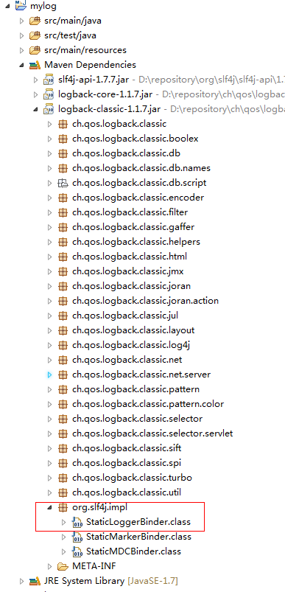

　　那么logback与slf4j就关联起来了，接下来看logback对配置文件的加载。我们回到bind方法，跟进StaticLoggerBinder.getSingleton()，方法很简单

public static StaticLoggerBinder getSingleton() {

　　return SINGLETON;

}

　　很显然，执行此方法之前，对配置文件的加载已经执行完了，也就是说在编译器已经完成对配置文件的加载了。那么我们需要换目标跟进了，StaticLoggerBinder中只有一段静态块

static {

SINGLETON.init();

}

　　那么我们跟进init方法

/\*\*

\* Package access for testing purposes.

\*/

void init() {

try {

try {

// 上下文初始化器

new ContextInitializer(defaultLoggerContext).autoConfig();

} catch (JoranException je) {

Util.report("Failed to auto configure default logger context", je);

}

// logback-292

if (!StatusUtil.contextHasStatusListener(defaultLoggerContext)) {

StatusPrinter.printInCaseOfErrorsOrWarnings(defaultLoggerContext);

}

contextSelectorBinder.init(defaultLoggerContext, KEY);

initialized = true;

} catch (Throwable t) {

// we should never get here

Util.report("Failed to instantiate [" + LoggerContext.class.getName() + "]", t);

}

}

　　接着跟进上下文初始化器的autoConfig方法

public void autoConfig() throws JoranException {

StatusListenerConfigHelper.installIfAsked(loggerContext);

// 寻找默认配置文件

URL url = findURLOfDefaultConfigurationFile(true);

if (url != null) {

configureByResource(url);

} else {

Configurator c = EnvUtil.loadFromServiceLoader(Configurator.class);

if (c != null) {

try {

c.setContext(loggerContext);

c.configure(loggerContext);

} catch (Exception e) {

throw new LogbackException(String.format("Failed to initialize Configurator: %s using ServiceLoader", c != null ? c.getClass()

.getCanonicalName() : "null"), e);

}

} else {

// 没有找到配置文件，则使用默认的配置器，那么日志只会打印在控制台

BasicConfigurator basicConfigurator = new BasicConfigurator();

basicConfigurator.setContext(loggerContext);

basicConfigurator.configure(loggerContext);

}

}

}

　　跟进findURLOfDefaultConfigurationFile方法

public URL findURLOfDefaultConfigurationFile(boolean updateStatus) {

// 获取当前实例的类加载器，目的是在classpath下寻找配置文件

ClassLoader myClassLoader = Loader.getClassLoaderOfObject(this);

// 先找logback.configurationFile文件

URL url = findConfigFileURLFromSystemProperties(myClassLoader, updateStatus);

if (url != null) {

return url;

}

// logback.configurationFile文件没找到，再找logback.groovy

url = getResource(GROOVY\_AUTOCONFIG\_FILE, myClassLoader, updateStatus);

if (url != null) {

return url;

}

// logback.groovy没找到，再找logback-test.xml

url = getResource(TEST\_AUTOCONFIG\_FILE, myClassLoader, updateStatus);

if (url != null) {

return url;

}

// logback-test.xml没找到，最后找logback.xml

return getResource(AUTOCONFIG\_FILE, myClassLoader, updateStatus);

}

　　自此，问题2的答案也清楚了，编译期间logback就完成了对配置文件的加载。

**总结**

　　编译期间，完成slf4j的绑定已经logback配置文件的加载。slf4j会在classpath中寻找org/slf4j/impl/StaticLoggerBinder.class(会在具体的日志框架如log4j、logback等中存在)，找到并完成绑定；同时，logback也会在classpath中寻找配置文件，先找logback.configurationFile、没有则找logback.groovy，若logback.groovy也没有，则找logback-test.xml，若logback-test.xml还是没有，则找logback.xml，若连logback.xml也没有，那么说明没有配置logback的配置文件，那么logback则会启用默认的配置(日志信息只会打印在控制台)。

　　slf4j只能绑定某一个特定的日志框架，若没有绑定，则会有如下警告，说明没有找到合适的日志框架

SLF4J: Failed to load class "org.slf4j.impl.StaticLoggerBinder".

SLF4J: Defaulting to no-operation (NOP) logger implementation

SLF4J: See http://www.slf4j.org/codes.html#StaticLoggerBinder for further details.

　　若找到多个日志框架，slf4j会发出警告，并在运行时抛出NoClassDefFoundError异常

　　最后来一张图

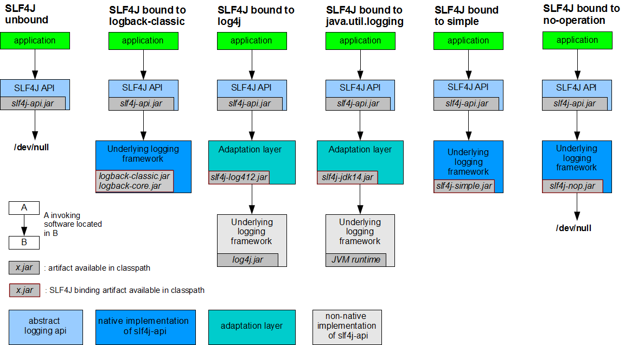

分类: [日志系统](https://www.cnblogs.com/youzhibing/category/1001590.html)

标签: [slf4j](https://www.cnblogs.com/youzhibing/tag/slf4j/), [logback](https://www.cnblogs.com/youzhibing/tag/logback/), [日志系统](https://www.cnblogs.com/youzhibing/tag/%E6%97%A5%E5%BF%97%E7%B3%BB%E7%BB%9F/)